|  |  |  |  |  |  |  |  |  |
| --- | --- | --- | --- | --- | --- | --- | --- | --- |
| **MAD Project Evaluation 1 – Regular Intake 2020** | | | | | | | | |
| **Group Name:** |  | | **Group ID:** |  | **Batch:** |  | | |
| Student ID | Student Name | Consistency (Out of 2) | Appropriateness and Professionalism (Out of 3) | Usage of resource manager (Out of 4) | Out of box design ideas (Out of 3) | Report (Out of 8) | Total (Out of 20) | Comments |
| IT19207100 | A.G.S.P.Deshapriya |  |  |  |  |  |  |  |
| IT19152110 | K.D Rajapaksha |  |  |  |  |  |  |
| IT19210520 | M.R.U.M Senevirathna |  |  |  |  |  |  |
| IT19210698 | J.M.V.L Jayasinghe |  |  |  |  |  |  |
|  |  |  |  |  |  |  |  |

Git Repository Link:

----------------------------------------------------------------------------------------------------------For Evaluators use only---------------------------------------------------------------------------------------------

Evaluator’s name:

Others:

Introduction to the project

**IT19207100 – Vehical Management (Admin)**

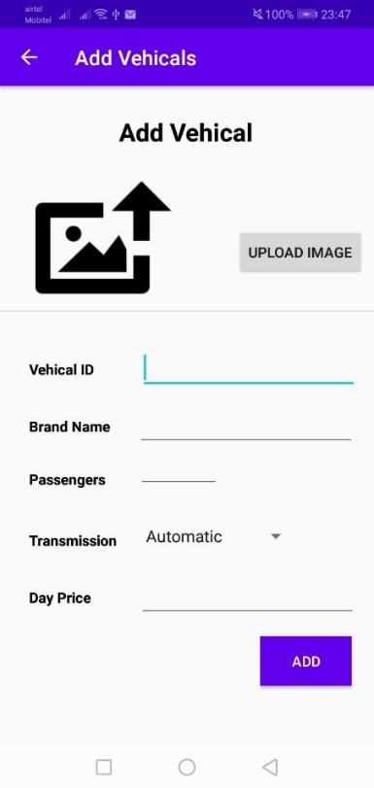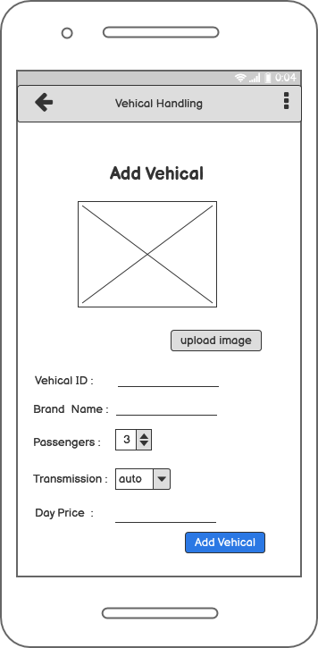

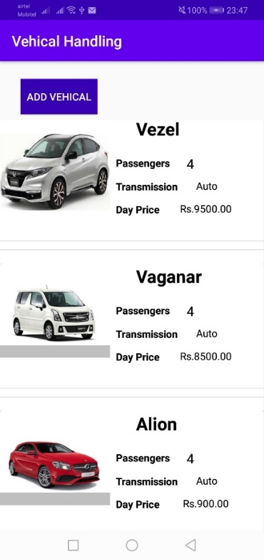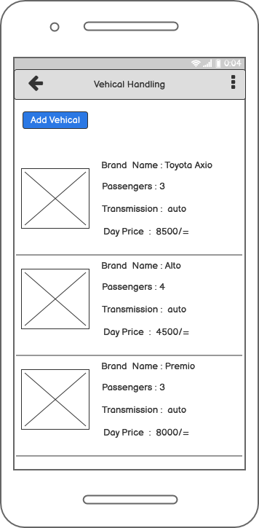

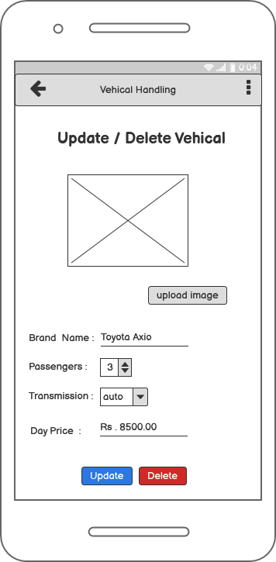

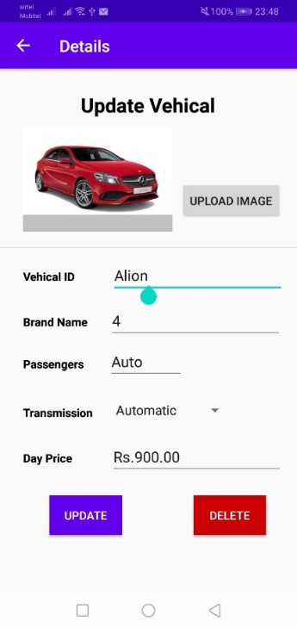

**Usage of resource files:** **CRUD operations and the entire functionality of the component**

CRUD operations

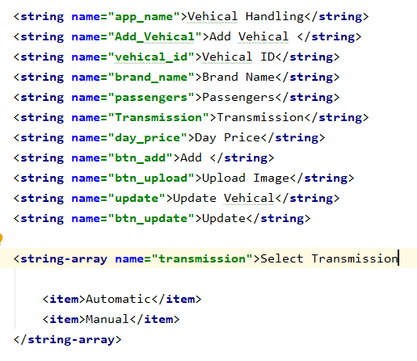

* Shop owner add new Vehicals to the app.
* Shop owner can see the current list of vehicals.
* Shop owner can update the current vehical.
* Shop owner can delete the current vehical.

After Shop owner login to the App he can choose vehical handling button, then app will appears the vehical handling section. In this section, Shop owner can view, add, update or delete a vehical in the current vehical list.

Layout Connectivity

If Shop owner click the add new vehical button, app will appears the form to fill the new vehical details (Shop owner can add new vehical by entering the vehical id, brand name, passengers, price for day and upload an image).

After entering the details Shop owner can simply click the ADD button, then that vehical added to the vehical list. In this process app will appears the toast message of “New Vehical Added Successfully”. Then app will redirect to the vehical list.

If Shop owner wants to update or delete the current vehical, he can simply click the selected vehical which is in the list. Then app will go to the update vehical page. Shop owner can update the details. After update app will appears the toast message of “updated successfully” then redirect to the vehical list. And also he can delete the vehical, after clicking the delete button app will ask the dialog box “Are you sure want to delete this”. Then click the ok button app will appears the toast message of “Deleted successfully”.

**IT19152110– FAQ Management (Admin)**

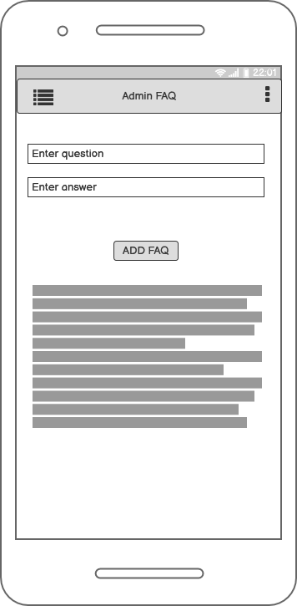

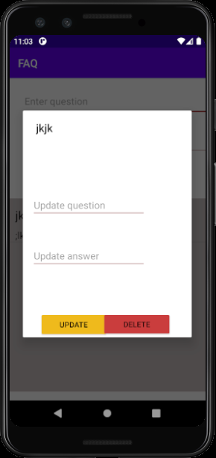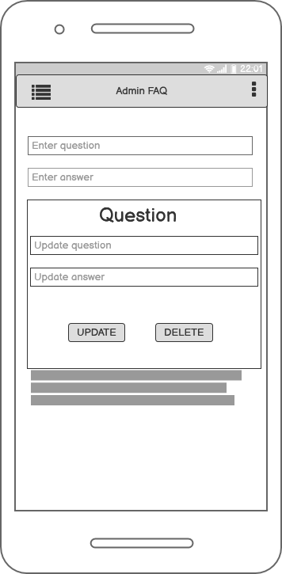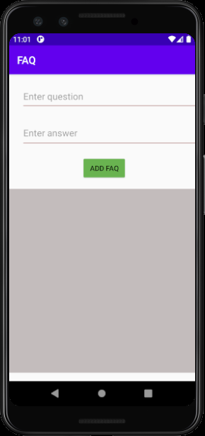

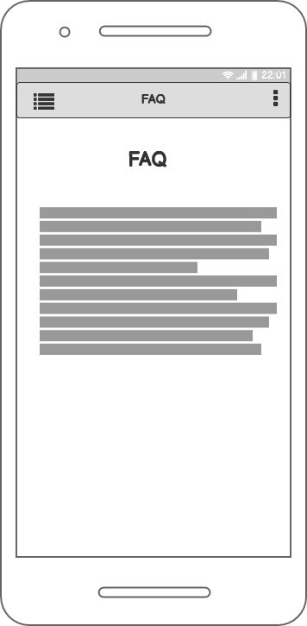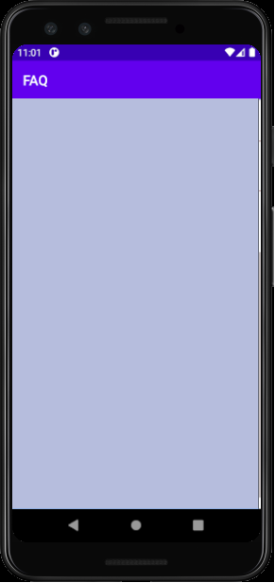

**Usage of resource files:** **CRUD operations and the entire functionality of the component**

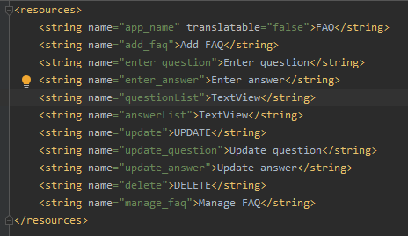After logged as admin. User can go to FAQ handling section by click FAQ handling button. User can add, update and delete FAQ through this function.

CRUD operations

Shop owner can add new FAQ to the app.

Shop owner can update current FAQ.

Shop owner can delete the current FAQ.

Shop owner can see current FAQs.

Layout Connectivity

If owner logged as an admin user can go to the FAQ handling section by pressing FAQ handling button. In this page there have an area to add a FAQ by enter question and answer. After enter those user can press "ADD FAQ"

Button and easily add an FAQ. If FAQ add successfully to database app shows "FAQ successfully added" message.

There have current FAQ list below the "ADD FAQ" button. If user wants to update or delete FAQ, user have long press particular FAQ.

After long press on particular FAQ app navigate to update and delete FAQ section. In this section user can change data and update FAQ by pressing update button. If user successfully updated FAQ, app shows

"FAQ updated" message.

If user wants to delete a FAQ, user can long press particular FAQ and navigate to the FAQ update and delete section and press delete button and delete particular FAQ. If FAQ delete successfully app shows "FAQ deleted" message.

**IT19210520– Payment (Customer) /Payment Management (Admin)**

**IT19210698– Vehical Booking (Customer)**